**Valid user account**: (not sure if I as supposed to do this to the windows machine, but I did it to the metasploitable through the netcat connection)

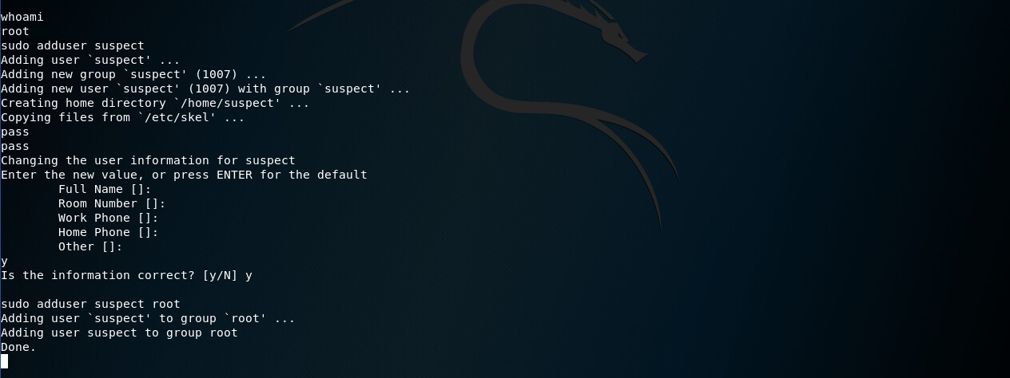

**Cron job / scheduled task:**

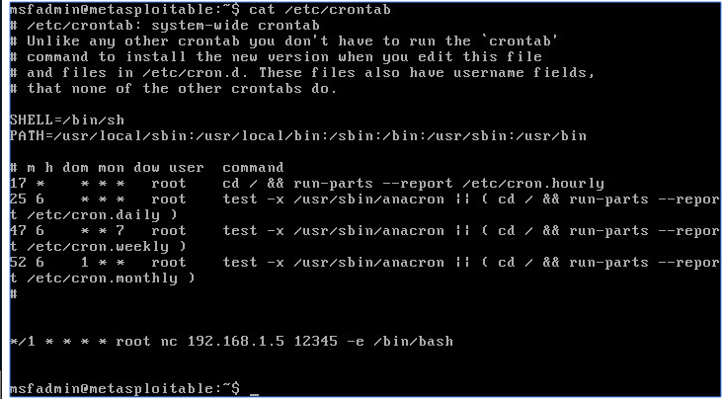

Meterpreter persistence script:

I had trouble getting onto a windows box, I’ll email you with my problem. also, my scripts appear outdated :/